Apply filters to SQL queries

Project description
The objective of this project is to analyze the organization’s data by examining the employees and log_in_attempts tables. Using SQL queries with filters involving AND, OR, and NOT conditions, I will retrieve relevant records to investigate these security concerns. This analysis aims to identify any suspicious activity, including failed login attempts or anomalies in employee machine usage, to bolster the organization’s cybersecurity defenses.

Retrieve after hours failed login attempts
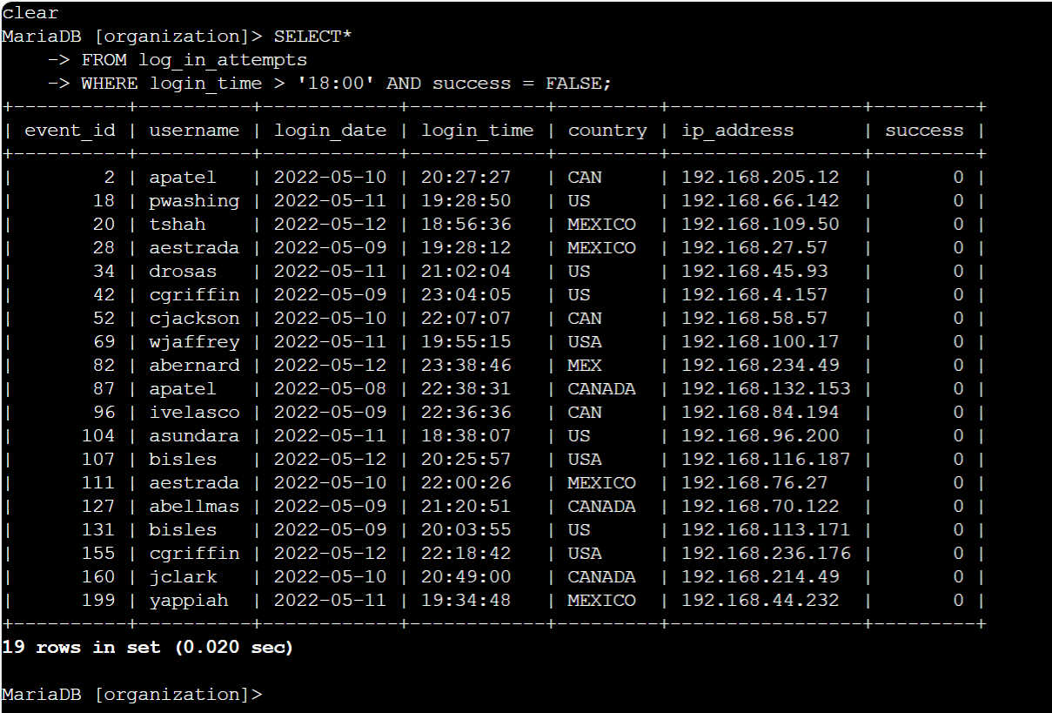

Retrieve login attempts on specific dates
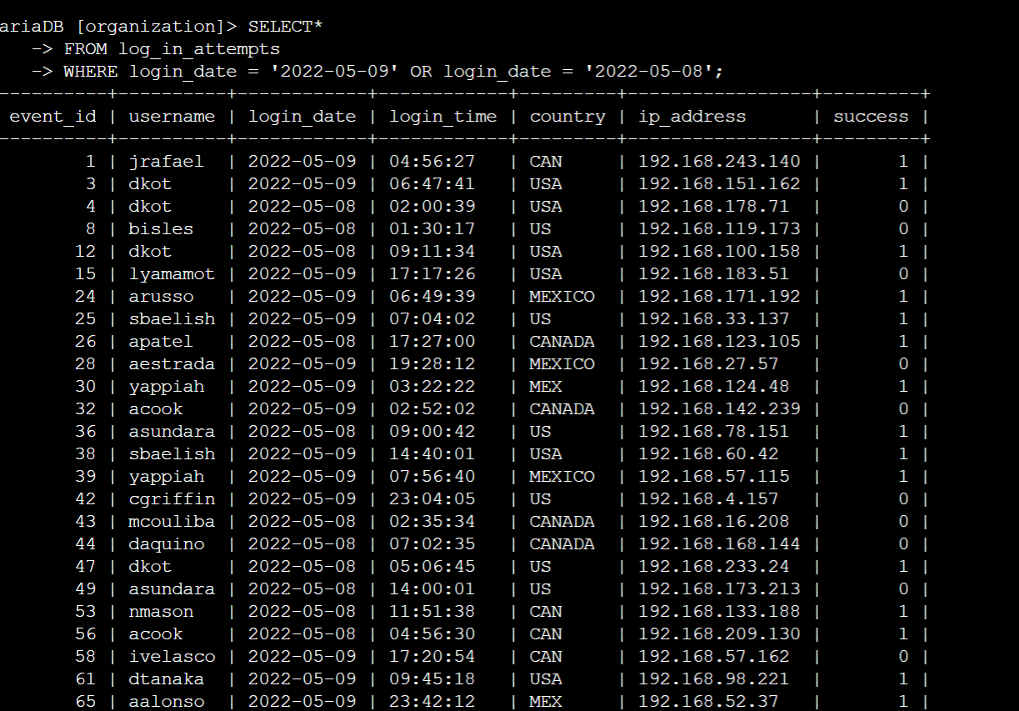

Retrieve login attempts outside of Mexico
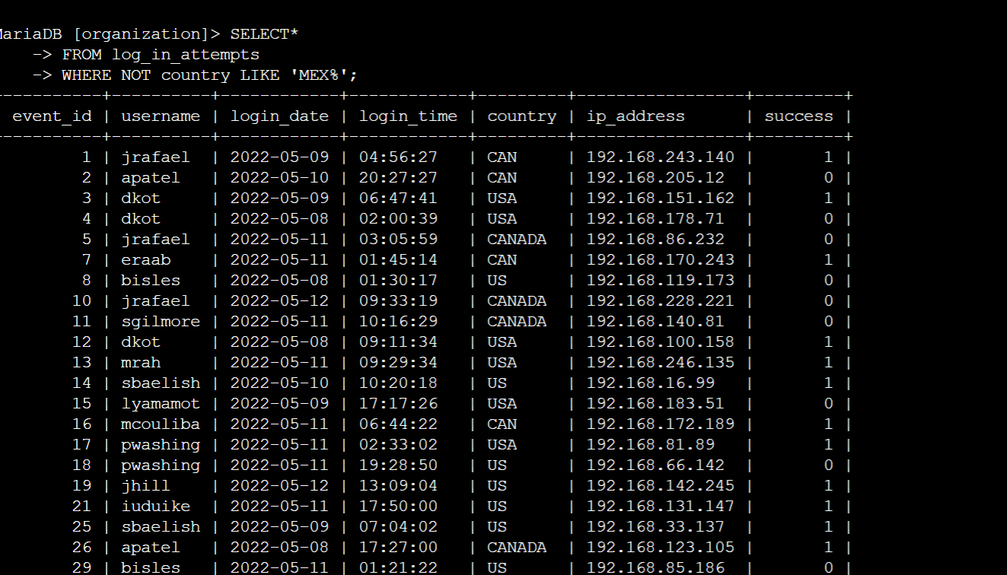

Retrieve employees in Marketing and in the East Building
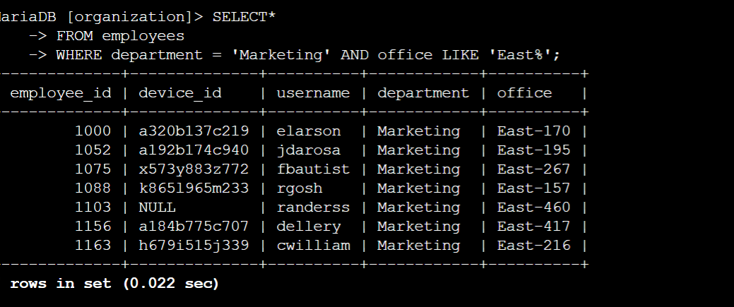

Retrieve employees in Finance or Sales
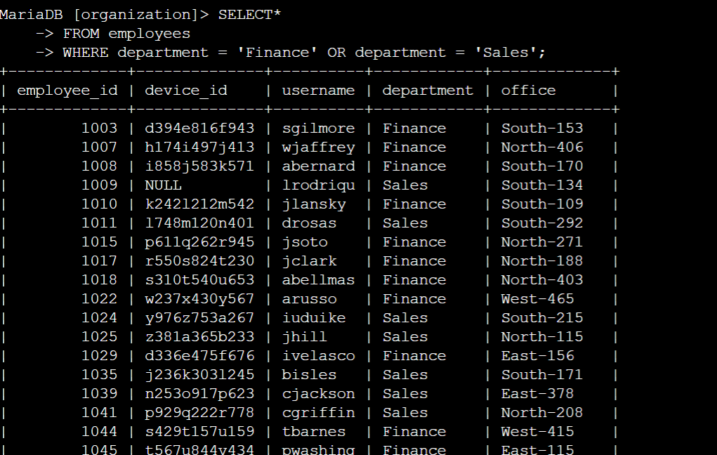

Retrieve all employees not in IT
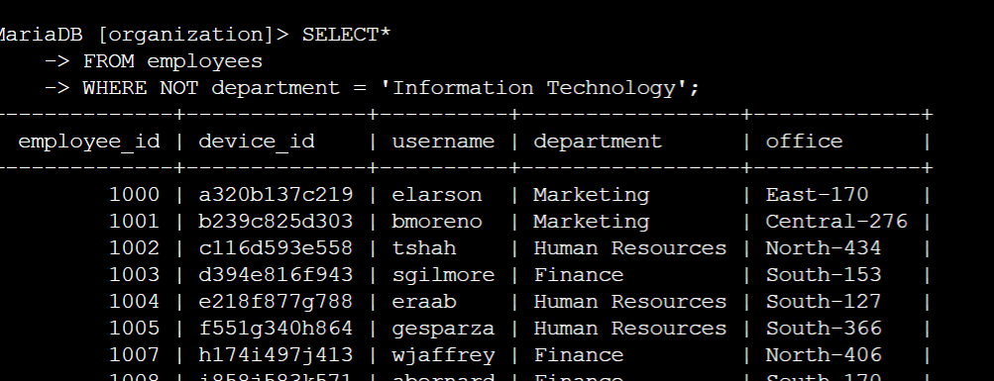

Summary
The investigation involved analyzing the employees and log_in_attempts tables to identify potential security threats related to login activities and employee machine usage. Using SQL queries with filters incorporating AND, OR, and NOT conditions, I successfully retrieved relevant records and uncovered patterns indicating suspicious or unauthorized activities. This analysis provided valuable insights into security vulnerabilities and helped strengthen the organization’s cybersecurity measures by highlighting areas that require further attention or immediate action.

